1.a) Describe the engineering significance of ‘strength of materials’. 3
b) Calculate the principal moment of inertia and their orientation for the given section about its centroid. 12
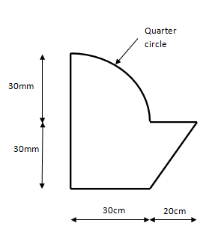
2. a) Derive the relation between Modulus of Elasticity, Modulus of Rigidity and Poisson’s Ratio i.e E, G and υ. 7
b) Find the load carried by each element and stress in each element. 8
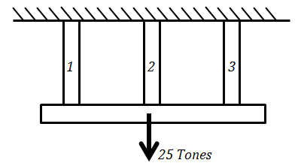 | Bars | Materials | Length (cm) | Area (cm²) | E(kg/cm²)
 | 1 | Copper | 4 | 5 | 1.3*10⁶
 | 2 | Zinc | 4 | 7.5 | 1*10⁶
 | 3 | Aluminium | 4 | 10 | 0.8*10⁶

3. a) The state of stress at a point of a machine is shown in fig. Determine the principal stresses and maximum shear stress and its inclination. 10
30MN/m²
30MN/m²
50MN/m²
50MN/m²

b) Determine external, internal and total static indeterminacy of the following plane frame. 5

4. Calculate and Draw AFD, SFD and BMD and indicate salient features if any. 15

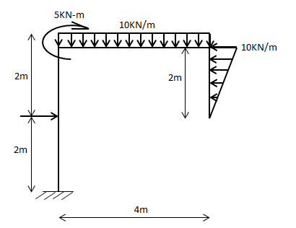
5KN
5. a) A timber beam 110mm wide and 220mm deep is strengthened by two steel plates 110mm wide and 20mm thick at top and bottom of the timber section. Find the moment of resistance of the section. Allowable stress in timber =7N/mm². Take E_{s}=20E_{t} 7
b) Derive the Flexural Equation. 8
Or
Derive Torsional Equation
6.a) What is the ratio of the strength of a solid steel column of 150 mm diameter to that of a hollow circular steel column of the same cross sectional area and a wall thickness of 15 mm? The two columns have the same length and similar end conditions. 8
b) A cylindrical shell 3m long which is closed at the ends has an internal diameter of 1m and a wall thickness of 15mm. Calculate the circumferential and longitudinal stresses induced and also change in the dimensions of the shell if it is subjected to an internal pressure of 1.5 MN/m². 7
7. Write short notes on any two. (2*5=10)
a) Shear stress on close-coiled helical spring
b) Classification of column according to slenderness ratio
c) Shafts on parallel and series, and subjected to Torque

